Applying Systems Theory to an Educational Setting

Part 1:
Applying Banathy’s Lens

Part 2:
Checkland’s Methodology:

University College of the North
Distant Education Division

Terralyn McKee

MDDE 603:
Athabasca University

February 10, 2008

Rick Kenny

I. Introduction
The educational system that I will be addressing for this assignment is a post- secondary institution, University College of the North (UCN). Being a long time resident of Northern Manitoba and a life long learner, I have had on-going contact with UCN (formerly known as Keewatin Community College) for over 20 years, in the role of student, Advisory Committee Member, and now as an instructor. I have had the opportunity to experience, and participate in, shaping the institution’s growth and evolution for over the past 20 years.
II. Organizational Features
UCN hosts the largest educational catchments area in Manitoba with a geographical and demographic diversity that poses critical challenges to institutional resources and educational strategies. The population of 77,548 residents is dispersed across 387,146 square kilometers of rural/remote land mass. The culture and ethnicity of residents is largely Aboriginal and Métis peoples, followed by non-aboriginals. The majority of northern communities have a population base of less than 1,000 people. University College of the North (UCN) has with two main campuses located in northern Manitoba, one in The Pas and the other in Thompson. In addition, the institution supports 13 smaller regional campus sites within the northern area, located in more remote areas, the majority on first nations reserve communities.
In 2005, UCN expanded its educational mandate and authority by becoming a University College. As a provincially funded post-secondary institution, UCN now has the power to grant certificates, diplomas and degrees. A significant factor that adds to the systemic composition of this institution is the philosophical incorporation of First Nations governance structures and an educational pedagogy recognizing the cultural traditions of First Nations, Métis and northern residents. To support this end, UCN has adopted a tri-cameral system consisting of a Governing Council, Learning Council, and Council of Elders (Bill 20. University College of the North Act). The new governance structure is highly reflective of the regional and cultural identity of Aboriginal and northern learners.
The philosophical mandate has been made practice through academic endeavors focused on providing programs and support services which address the unique challenges that have been barriers to academic participation and success for Aboriginal learners (development of institutional policies and articulated systemic practices). Current institutional initiatives are underway to create, adapt, and support programs based on Aboriginal philosophies, historical knowledge and values, relevant practices, and specific Aboriginal ways of knowing (pedagogies) (Hart, 2002; Malatest, 2004, Mendelson, 2006, Newton, 2007; UCN 2004-2007).
In terms of educational activities, UCN is a dual model institution (Moore & Kearsley, 2005) that offers on-site face-to-face instructional programming, and more recently, a small number of Distance Education courses. Recent administrative and organizational developments have proposed the creation of a formal Distance Education Department to improve educational access through distance delivery of many courses and degree programs.
III. Organizational Systems, Subsystems, Processes and Operations
As defined by Banathy (1992), the activities of the institution readily qualify as a ‘human activity system’, making it well suited to a soft systems study. The organizational components, as identified by Moore and Kearsely (2005), cover a diverse range of activities normally associated with educational institutions such as 1) learning 2) teaching 3) communication 4) design 5) management, and 6) institutional history and philosophy. Cookson (1998) has qualified these components as sub-systems that make up the system of education. However, he does point out that each component, or subsystem, exists as its own entity and comprises a system of operation within them. There are a multitude of activities that take place within each of these systems that interact to produce feedback, which in turn, supports the on-going activity of the system at large.
An articulated summary of the program, its structure and components is addressed in the following diagrams/table taken from systems theory. The first is a simple systems diagram which defines general categories of features which make up the overall environment of the educational system under review.

Figure 1: System Functions at UCN

Learning
Experiences
Governance
Structure & Activities
Administrative
Functions & Activities

Instructional
Elements

UCN
Gives input
Gives input
Gives input
Gives input
At the centre of the systems hub is the educational entity itself. The surrounding functions are identified as the core functional areas that support the educational goals of the institution. Each of these functional nodes can be considered a sub-system which contain and organize similar task goals; thus promoting efficiency – a characteristic of a self-organizing system. An open relationship exists between the systems as denoted by the dotted lines. This on-going communication informs the processes and allows for feedback loops to be formed assisting in adaptations and changes that promotes continued operations. The solid lines denote a relationship hierarchy – a connection of systems radiating out from the central hub that work in conjunction to achieve a common goal (Banathy, 1987; Frick, 1996).
Banathy, 1987; Reigeluth,1995; Frick, 1996
Overall, the above information briefly describes the general environment of the system - geographic, demographic, economic, social, technological, cultural, ideological/political, and historic factors. According to Cookson’s (1998) review of Banathy’s work, identifying these functions is critical in understanding and planning for an effective systems analysis. The very nature of systems theory states that effective systems models cannot be developed in isolation of general and specific environmental factors.

The components share an equality that emphasizes the importance of their relationships and their interdependence, thus defining the system. UCN is moving from the traditional educational hierarchy which focuses on the teacher as the focus on knowledge creation and distribution toward a model of shared control of the process, with accommodations to both educational content and context (Frick, 1996).

Teacher

Student

Content

Context
Education System
Figure 2: Specific System Environment

This diagram represents a specific systems environment that ought to exist within education. The components have been defined as subsystems that share particular relationships and through these interactions define the overall activities and goals of the educational system. These four components have come to be known in distance education as transactional distance (Anderson, 2004).
Institutional components and tasks further define the operational process of the educational institution. The components listed in Table 1 provide an abbreviated listing of elements provided in Cookson (1998) and Banathy’s work (1995). Identification of system components will vary based on the perspective of parties involved in the analysis. The following list in not a comprehensive listing of the components, inputs, outputs and feedback but does represent a general overview of processes occurring within the UCN model.

IV. System Components and Feedback Mechanisms
Table 1: Educational Components, Tasks, and Feedback Mechanisms
Environmental System | Specific Environmental System and Tasks | Feedback  Mechanisms
Learning Experiences | Student  - Learning/communication styles and relationships  - Peer connections  Environment - context  - face to face  - distance  - physical structures  - support systems – personal, academic and education processes  - technology | Student evaluation on diversity styles of information experienced with materials  Self report on success of accessing support systems  Withdrawal, success and failure rates within programs  Number and types of calls to help desk
Instructional Elements | Teacher  - content expert  - instructional style  - communication and relationship styles  Content  - cognitive – connotative – affective (teacher-student)  - curricula – pedagogy and organization of  - course design and production  Environment  - integration and use of technology  - support systems within technology-based instruction system for teacher  Frick (1996) | Student evaluations  Course enrollment figures  Course completion figures
Administrative  Functions & Activities | Policies  - course requirements  - accreditation / transfer  Processes  - enrollment, withdrawal, completion | Information about instructional needs  Application and enrolment statistics  Interdepartmental assessment of communication efficiency – back logs, delays, turn around time
Governance  Structure & Activities | Institutional history  Philosophy  - core values and practices  - institutional pedagogy  Governance structure  - Boards  - Committees  External governing organizations / stipulations | Levels of faculty participation and satisfaction in governance processes  Accreditation approval
A final note regarding Feedback Mechanisms within the educational system; feedback can take a variety of forms based on the information required by the analyst. Essentially however, feedback is concerned with qualitative information about the throughputs, or processes, of the systems which produce the outputs. This information is essential for monitoring, evaluating, and guiding the performance of the system, within subsystems or as a whole. Questions answered by feedback include quantitative and qualitative data – how much, how many, numbers and types of errors or mistakes, comparative reports, satisfaction surveys, analysis and test results. This information can then return through the system in the form of inputs to modify or change ineffective processes.
V. Application of Banathy’s Lens
With respect to a systems analysis for the UCN educational model I have chosen to employ Banathy’s Systems-Environment Lens as outlined by Cookson (1998). As previously presented, the complexity of environmental influences being currently exerted on UCN during this transitional period is highly significant. The very nature of the institution’s identity within the post-secondary community has undergone an external transformation with its move from a community college to a University College model. Internally, the transformation toward a more relevant pedagogy has meant tremendous change for the institution and its alliances in the academic world, for faculty and their instructional content and context, as well as students and communities served by UCN. It is certainly relevant at this time to consider Banathy’s challenge to assess environmental response to the current systems path. “By asking questions using this lens focus, we can assess the environmental adequacy of the environment’s response to the educational system.” (Cookson, 1998. page 5).
The system-environment model depiction is the one most frequently associated with systems theory – showcasing the inputs, throughputs, outcomes and feedback processes most effectively. It provides the “landscape” view of the system parts and relationships nested within each other to provide an orientation to the interactions and interdependencies of the overall system – the fundamental definition of the system and its processes. The systems environments presented include the general environment and the systemic environment. Table 2 summarizes the general environment influencing UCN’s attempts to develop a distance education division.

Table 2 : Banathy’s Systems Environments Lens - General System Environment
Geography – as per Organizational Features
Demography - as per Organizational Features
Economic – resource-based industry; high unemployment rate; poor economic stability for many residents
Social –moderate to low levels of stability based on economy, crime rates, poverty, health indicators, vulnerable populations; fractured communication across cultural boundaries
Technology – moderate levels within UCN; moderate reliability with web connections and access; limited number of platforms, software and new technologies
Cultural – as per organization features
Ideological/Political - as per Organization Features
Geography – as per Organizational Features
Demography - as per Organizational Features

Systems theory defines several distinct processes that comprise a functioning model. The previous descriptions have focused on attributes and influences of the system. These elements consist as part of the ‘inputs’ that shape the activity of the system. These inputs undergo a ‘transformation’ to create outputs, which the system uses to support its purpose (Cookson, 1998). Inputs and outputs can originate from either the general environment or the systemic environments through breaks in the system barriers that identify it as an open system. Table 2 examines the inputs and outputs of the process underway for UCN.

Table 3: Systemic Environmental
Defined Inputs | University College of the North
Expectations | UCN is a dual-mode institution offering face to face instruction at two main campuses and 13 regional campuses; UCN also offers a limited number of courses via distance – correspondence and technology-based.
 | Adult basic education, certificate, diploma and undergraduate courses are available. Graduate programs are planned for the near future.
 | Prior learning assessment recognition and competency-based delivery methods are offered as alternate forms of course credit recognition.
Policies | Designation of governance structure – Governing Council, Learning Council, and Council of Elders
 | Institutional Ethics and HR/Administrative operations based on the Seven Sacred Principles
Constraints | Curriculum development capacity for distance delivery has been left to course instructors.
 | Financial resources needed to organize and implement the processes.
 | Faculty resistance to yet another change – concerns about intellectual property rights – faculty down-sizing if expert content embedded in distance programming – increased work load without appropriate compensation.
People | -community college / trades professionals -university faculty -administration and support staffing -counselors, academic resource, IT - sponsors, sector councils, communities
Money | Council on Post Secondary Education determines the funding rates for UCN and types/numbers/conditions for accredited programs -current growth and change rates (capital expenditures, programs and staffing) are outstripping the funding schedule
Materials | -technology – upgrades, access, reliability, stability, user ease - integration of materials access (bookstore) through distance
Outputs
Activities | Accommodation of cultural epistemology into programs and course content. Course offerings in all regions served by UCN – extended access internationally if applicable. Number of enrollments and program graduates (once program is operational).
Resources | Increasing accessibility to adult learners and remote students. Creation of a UCN community for Aboriginal learners.
Requests and Requirements | Requests for specialized staff and equipment has been received from faculty and departments within UCN.
The outputs are hypothetical for the actual operations and outputs of a DE department. Discussions have generated a mixed bag of requests and suggestions to accommodate the best possible system development.
Summary
As Cookson (1997, p. 9) observed, “…..universities have defined themselves within the culture of the past.” Historically, that would have been a truism for UCN (previously Keewatin Community College). However, nothing could be further from the truth at this stage of the institution’s growth. The radical changes happening across the organizational spectrum has caused ‘reaction’ of resistance both in the general and systemic environment. Fear of the unknown is a powerful motivator to accept, and in fact embrace, status quo thinking. The current state has rendered the Reactive Orientation obsolete – many instructors have already left the institution because they found their positions futile and were unwilling, or unable to adapt the environment of change.
There are precious few Inactivists left within the system as well. They do provide a base for maintaining the previous organizational culture, which at times has been helpful. As a survival strategy however, it has proven quite ineffectual.
The current contingent of administrative forces consist of Preactivists and Interactivists. Erring on the side of caution, it would be safe to say that the present course is being guided by the Preactivists who are attempting to read the change signs in the external environment to plan for change – meeting the curve rather than anticipating and predicting it.
The Interactivist thinkers are in the key administrative positions and are charting a course based on long-standing pressures to accommodate, in a meaningful way, northern and Aboriginal learners. They are charting courses where few educational institutions have successful gone. The true test of their vision will be their ability to guide all parts of the institutions down the same path at the same time. Using a systems model could aid in that endeavour. This ‘co-evolution will determine the actual inputs, throughputs and outputs of the system.
Part 2: Soft Systems Methodology (SSM)
I. Introduction
Analyzing problems that arise in human activity systems (HAS’s) provides unique challenges given the ‘fuzzy’ nature of the issues and the culture in which they arise. Processes used in hard systems analysis are less effective in this area because of their reliance on rigid application of hierarchical system analysis, their reliance on precise issue definitions, and the practice of isolation of the control processes (Jarvis, 2003). Hard system analysis optimally responds to problems arising within a contextual environment dominated by hardware or machine-based settings – very predictable and slow to change, concrete in nature with high degrees of agreement of issue and problem recognition. Unlike human systems that by their very nature rely on the perceptions and interpretation of individuals, hard systems do not have to accommodate uncertainty or changing problem-perceptions (Naughton, 1984). Systems that are defined by their relationships with respect to human activity are not easily reduced to such tidy processes of decomposition. Reaching consensus on the definition of objectives, processes and issues within human systems is the task of soft systems analysis.
Checkland presents a seven stage model to assist in clearly defining problem situations within organizations and delineating a problem-solving strategy. Each stage of this process provides a defined activity to elucidate the unique attributes of the problem situation and people/systems closely associated with and affected within the system.
Background: UCN Distance Education
As presented in Part 1 of this assignment, University College of the North (UCN) is an open system struggling with development and growth issues presented by their transition from a small trade’s college into a University College. The issues arising across multiple fronts are complex and interrelated – a “mess” as Ackoff would state (Banathy, 1995).
The area of specific focus chosen for this review is the Distance Education component at UCN. Current operations support limited distance delivery across a small number of faculties. While Moore & Kearsley (2005) would define this approach as a dual model, there are few organized resources devoted to the coordination of distance development and delivery. The approach has been piecemeal at best with content conversion to distance delivery being accommodated by individual instructors. The course goals, objectives and learning activities are not guided by e-learning’s best practices and success of students (particularly Aboriginal students) is generally dependent upon the skill level and relationship commitment of the instructor (Newton, 2007).
Course delivery mechanisms include correspondence, asynchronous and synchronous courses via Desire to Learn, Elluminate, videoconferencing, and audioconferencing. The IT department at UCN maintains a distributed network on both main campuses and Internet based connections in each of the 13 regional centres. Distance Education facilitators are on site at the main campuses and contract Regional Directors are available to support the technical connections necessary to maintain computer mediated access and audio/visual conferencing equipment.
Based on previous experience and current market trends, UCN recognizes the untapped potential of a well-developed, supported and coordinated Distance Education Division (Province of Manitoba, 2000). Based on feedback from past DE practices, advisory consultations with students, instructors and communities, and review of institutional processes and support systems, UCN is moving forward to implement Distance Education services (UCN 2004-2007).
Stage 1: The Problem Situation Unstructured
Stage 1 of Checkland’s Methodology involves developing a very broad expression of the problem situation without defining ‘problems’ per say. Maintaining an objective distance, or ‘vagueness’, allows for a richer analysis of the situation and the problem from multiple perspectives (Naughton, 1984). In the case of UCN, this was done by reviewing the current structure, faculty, courses, pedagogy, current capacity, perceived strengths and challenges of the institution, and the potential impacts of adding another educational division, from the perspective of all parties involved.
The Soft System Analysis is managed by the individuals involved with the system. Facilitation is provided by the consultant, who is a part of the organizational system during this process. The first stage requires examination of the problem situation and systematic collection of organizational information and perspectives of individuals impacted by the processes. The collection methodology needs to allow for reflection and use at each of the following stages by various individuals and groups of individuals within the system to fully articulate the issues and primary task. The following table has been constructed using Checkland’s model to identify the roles that comprise the organization and their relationship to the problem situation.
Table 4: Problem Situation: UCN Roles and Relationships
Initial Problem Statement | Design, development and implementation of an integrated distance education department offering a wide range of courses which reflects the institutional commitment to promoting the unique profile of First Nations learners.
Client | Linda Melnick, Director of Academic Development
Problem Solver | Linda Melnick, Director of Academic Development Daryl Kines, Director of Information Technology Distance Education Coordinator
Possible Problem Owners | Director of Academic Development Distance Education Facilitators (main campuses) Regional Centre Directors Students; UCN Libraries staff; IT and Academic support staff; clerical staff; Faculty Department Heads; Distance Education Coordinator; Curriculum Development Coordinator
People to Interview | Distance Education Facilitators (main campuses) -Doris Shand* and Bruce Farquarson Regional Centre Directors (13) - 1 Director was interviewed (Flin Flon)* Students – past Distance learners / potential Distance Learners - 4 students were interviewed* UCN Libraries staff - Shannon McAlorum*, Stan Gardner, Shelly Doman IT and Academic support staff -IT (Darly Kines*, Dan Wilchowy*, Carol Reimer); Support Services (Tanya Carriere, Phyllis McLeod, Carol Girling*, Monica Cook, Konrad Jonasson) Clerical staff -Janet Sinclair, Donalda Gale*, Kathy Ducharme, Susan Bell Faculty Department Heads -Linda Melnick*, Rob Penner*, Selvin Peter, Kathryn McNaughton, Al Gardiner, Peter Geller, Connie Pringle, Alfred McDonald Distance Education Coordinator Curriculum Development Coordinator Instructors – currently DE / proposed DE - Brenda Wasylik*; Cindy Nordick, Sue Matheson*, Terralyn McKee, Will Trowel* Employment and Community Stakeholders -Employment and Training*, HRDC, Sector Councils*, Band sponsors
Based on a Table from Giroday (2004).

Given the time constraints of this project, only the individuals listed with an astrix were interviewed. In addition to the interviews, systems information was used to construct the Rich Picture. The systems information utilized included department studies, internal summary documents, UCN Summary Reports, Activity Summaries, and Advisory Committee Minutes (UCN 2004-2007).
It should be noted that there was not an open consultation on the development of a Distance Education Department. These discussions were held at the management level with a trickle down effect with information pooling within various departments that would ultimately be affected by the creation of a new department. Perceptions and reactions varied radically depending upon how far down the hierarchical ‘food chain’ an individual was placed. Initial perceptions at management level envisioned a small endeavour - the addition of a few new positions but a critical restructure of existing positions and resources within UCN to accommodate a modest entry into the DE field. Departments tasked with the potential accommodation of DE activities expressed different visions of the type, range, and level of activities to be undertaken by this venture. Most expressed deep concerns about additional work loads without additional staffing or budgetary resources. Individuals (students, instructors) most affected by the creation of a DE department varied greatly in their response as well. Extremes ranged from anxiety (learning new technologies, increased work loads, complicated systems and resource management), skepticism (do we really have the resources, are ‘we’ ready to navigate the technology), to elation (it’s about time, what a great opportunity, sign me up now!). These facts, perceptions, and opinions provided a very ‘rich’ opportunity to diagram the ‘mess’.

Stage 2: Rich Picture, Issues and Primary Tasks
The Rich Picture information included in this project is based on the issues facing the development of an integrated Distance Education Department amidst the current change processes already taking place within the University College. The issues articulated within the Rich Picture reflect a collection of findings presented from interviews, organizational documents, and Advisory Committee meetings.
Stage 1 allowed for the examination of the problem situation from multiple perspectives. The information collected included factual information (enrolments, completions, applications, policies, finances, faculty contingents, etc) and soft information (interactions, perceptions, alliances, opinions, fears, etc). The organization of this information is the next crucial step in problem-solving. I found it useful to construct a table to assist in this organization based on Checkland’s discussion of structural elements, process elements, and interaction/relationship processes before creating the Rich Picture. Given the amount of information and complexity of the problem situation, this list is only a partial representation of the whole – enough to provide an overview for this paper (Naughton, 1984).

Table 5: Elements of Structure, Process, and Interaction/Issues
Structure | Process | Interaction/Issues
Governance – parties and policies | COPSE – changing accreditation and institutional responsibilities to meet legal obligations under the Act.  Province of Manitoba – granting of University status and changes in institutional identity  Other post-secondary institutions – recognition of course articulations and credit transfers | Perceived animosity from other institutions regarding granting of University status. Little support or networking unless it has direct benefits to the other institution. Perceived ‘snobbery’.  Challenges to changes in governance structures.  Accreditation reviews for one faculty dept have been overly stringent with inappropriate demands for detailed course plans, implementation strategies and evaluation components.
Institutional Structure | University level courses, certificates, diplomas, degrees  Governance structure revisions to accommodate shift toward Aboriginal access and service provision  Incorporation of Learning Council and Council of Elders into governing bodies | Turn over in old faculty and addition of new faculty members (University) has left feelings of anxiety, fear, anger, and betrayal for some faculty.  Consensus model presented with information and decisions pre-determined.  Confusion re: revision and implementation changes to accommodate Aboriginal learners.  Trades and diploma programs not linked to or communicating with University programs. Division? Value? Priorities?  So many changes happening that feelings of “being lost”, “overwhelmed” and “confused” are emerging.
Physical sites | Geographic area as a barrier to educational access  Main sites – bldg inadequacies – size, space, access, design.  Regional Site inclusion and accommodations | UCN is having difficulty supporting current prgs – our infrastructure will not accommodate more services  We (external sites) are the last to receive prgs – always compromising on delivery because of shortages (staff, books, student space, etc)  We could meet more student trng needs if you (UCN) would come to us – too expensive to send our students to main campuses.
Administrative services | Student supports inadequate for current programming  Funding access and reductions to other departments to support DE | Need more supports to accommodate ‘mature student’ – LD students – relocation from home cmty creates more than academic issues  Integrated upgrading and tutorial services need more emphasis.  Paper work in satisfying sponsors, tracking students, interrupted education, etc is challenging
Distance Education Division | Staffing – commitment to fund and staff at req. levels  Priorities for curriculum development/conversion into DE access | Mgmt team is required to create an ‘integrated’ prg  Tasking req to existing staff only is not an option – req new staff and supports
Students | Current level of need to support academic progress  Compromised program quality  Isolation and success  Navigating equipment and program challenges | Enjoy the smaller class sizes and personal connections with instructor and peers.  Limited contact with IT – varying levels of satisfaction with IT issues.
IT and Computer – platforms, hardware, software | Cost of supporting new platforms and wares  Access and reliability issues for remote areas connecting via net  User issues and HELP resources  Translation of objectives into appropriate digital models  Interconnectedness of learning objects and data basing them  Maintenance of materials and processes | Ltd resources (equipment) available in regional centres – scare in other remote cmts  Integrated platform to accommodate ‘learning object repository’ will req time/$  Current staff working at max to accommodate current tech needs  Maintenance of prgs an issue  Little pre-planning btwn IT and faculties/individuals  User errors high – faculty not trained in program use and operations.
Faculty | Intellectual property rights  Compensation for development – time and money  Training to remain current with technology  Support with conversion of courses into effective distance learning models  Class sizes for online  Predictability and reliability of equipment and software | Poor communication between faculties regarding changing curriculum requirements.  Currently limited contact with IT  Equipment issues and system reliability  Introduction of blended teaching styles in classrooms
Other  Employment, Training, and Sponsors | Market Demand- awareness of employment demands within the region that individuals could fill with appropriate trng/ed  Identification of eligible individuals  Community Contracts-dev of contracts wi cmts to meet employment needs and opportunities  Tracking student progress and success rates from institution  Institutional Supports to increase success rates of students | Demand for skilled employees has outpaced supply – economic growth is threatened  Employment opportunities in the north are going to non-residents – no primary economic benefits only secondary (unstable – short term) gains for northern communities  Gap in education and employment levels for Aboriginals – no sustainable dev on reserve cmts due to lack of industry, training and employment  Market trends and employer needs tracked and forwarded to institution to meet demands
Adapted from Giroday (2004); DuMont (2002).

Issues summary – it is apparent that there are a multiplicity of issues emerging from within each of the structures and processes listed above. It is also apparent that there a number of themes (patterns) emerging from within the issues that can be isolated and articulated as they relate to the primary task of the institution – the education of individuals at a standard supported by external controlling agencies, which supports the needs of industry and communities.

Table 6: Institutional Issues
Issue 1 | Governance policies and practices which support external criteria and legitimacy for operations as a post-secondary institution.
Issue 2 | Recognition of First Nations status and needs through governance structures and educational processes and practices.
Issue 3 | Meeting the needs of industry and communities in providing access and supports to programs which create economies

The other set of issues emerging specifically from the problem situation can be summarized in the following issues:
Table 7: Problem-Situation Issues
Issue 1 | Need to meet external criteria with courses that are developed – quality and legitimacy of the DE activity
Issue 2 | Development process of a system that is well-resourced, user-friendly, accessible and reflective of student needs – incorporation of aboriginal pedagogy.
Issue 3 | Responsive and accountable to Sponsors and Employment sector needs.

There are common goals expressed in both sets of issues, however, Naughton (1984) warns that it is the differences that provide the richest area for consideration when constructing the root definition for the problem-situation.
*An ‘aha’ moment for me as I struggled with the complexity of this problem-situation, which I did not find clearly articulated in the literature, is that each component mapped on the rich picture has its own set of Primary Tasks and Issues. Separating these out and staying focused on the ‘problem’ situation was extremely hard! It was so easy to lose perspective and get pulled into another component and focus on its tasks and issues – muddying the waters of the analysis and causing untold confusion and frustration for me as I backtracked to figure out WHY my rich picture and relevant systems were NOT matching! It was a facilitator’s ‘processing’ error within the soft system methodology.

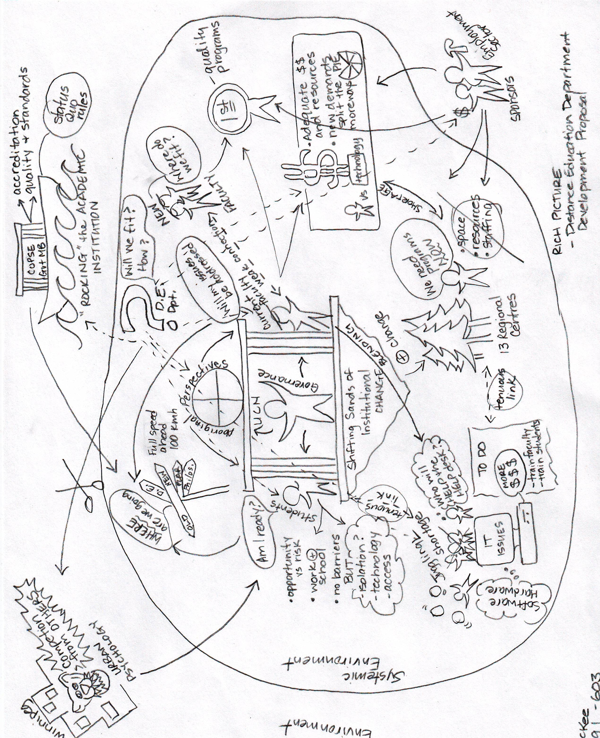
Stage 3: Relevant Systems and their Root definitions
Organization of this problem-situation was complex, profuse and rich. It is apparent that there are quite a number of processes and concerns being expressed about how a new department will be developed, staffed, funded and integrated into existing subsystems within the organization. Using this information, it is imperative to formulate a root definition that will focus the development of a conceptual model to address the expressed issues and relevant systems (Naughton, 1984).

Table 8: Relevant Systems of the Problem-Situation
RS 1: Educational | A system to bring about the education of individuals at a standard supported by external controlling agencies
RS2: Cultural | A system to frame the relevance of education within the pedagogical structure of First Nations individuals and communities.
RS3: Economic | A system to bring about the economic development and sustainability of individuals and communities in the North through appropriate (as manifested through demand) training and education.

Initial Primary Task Development based on issues –
University College of the North is a post-secondary academic institution, accountable to COPSE and the Province of Manitoba and committed to the needs of Aboriginal and northern learners. The assumption is that greater educational access through distance education by development, design, implementation, and coordination of academic course delivery within diploma/degree programs to northern students.

Root Definition Development incorporating the issues and relevant systems:
University College of the North, as a post-secondary institution is accountable to COPSE and the Province of Manitoba for achievement of set academic standards and fiduciary responsibility; accountability is extended to community sponsors and employment stakeholders in the development and implementation of training and educational programming sensitive to the needs of First Nations learners. The assumption is that Distance Education can increase access to training and education by reducing the existing barriers of geography and sponsorship costs while supporting Aboriginal pedagogy and values.

Table 9: CATWOE Process
Customer | Students will ultimately be the beneficiaries of Distance Education Division – greater access to education, reduction of geographic barriers, balancing of work and study responsibilities, etc
Actors | Director Academic Development, DE Coordinator, Instructors, IT department, Employment Sectors and Sponsors
Transformation | Information, knowledge, skills, and expertise (Cookson, 1997) of instructors and content experts are the system inputs which undergo a transformation within the processes of the system, resulting in Distance Education courses via print, computer mediated programs (power point, etc), conferencing tools, communication avenues (email, video conferencing, teleconferencing, etc).
Weltanschauung | Loss of market-share – other institutions actively marketing distance education programs within UCN draw area; expanding educational authority with University College designation; increased access to program funding; recognition of Aboriginal culture and status within political
Owner | UCN and COPSE are the primary owners of this system. Both have financial and accreditation responsibilities to ensure program credibility and viability. Student sponsors (individual bands and Education and Training) are owners of the system since they make the investment decisions which create demand for the programs offered. Communities at large act as quasi-owners by establishing demand within the market place for training and education.
Environmental constraints | UCN general environment is ripe with competing demands, trends and influences across political, economic, social, demographic, and technological boundaries.

Stage 4: Conceptual Model

Determining the ACTIONS of the Root Definition:
University College of the North, as a post-secondary institution is accountable to COPSE and the Province of Manitoba for achievement of set academic standards and fiduciary responsibility; accountability is extended to community sponsors and employment stakeholders in the development and implementation of training and educational programming sensitive to the needs of First Nations learners. The assumption is that Distance Education can increase access to training and education by reducing the existing barriers of geography and sponsorship costs while supporting Aboriginal pedagogy and values.
The conceptual model allows for planning of the “what ought to be” in terms or processes and operations within the institution. The model should acknowledge the components, issues and processes captured in the rich picture while organizing the parts into a coherent whole. Analyzing the root definition and providing animation to the ‘action’ statements guides the modelling process. For UCN and the creation of a new department, Distance Education, there are a plethora of issues compounding the process. By following the steps outlined by Naughton(1984, p 38-39), the problem-situation remains the focus and allows for consideration of the other issues without being derailed from the main objective – the root definition. See Figure 1 for Concept Map of problem-situation.

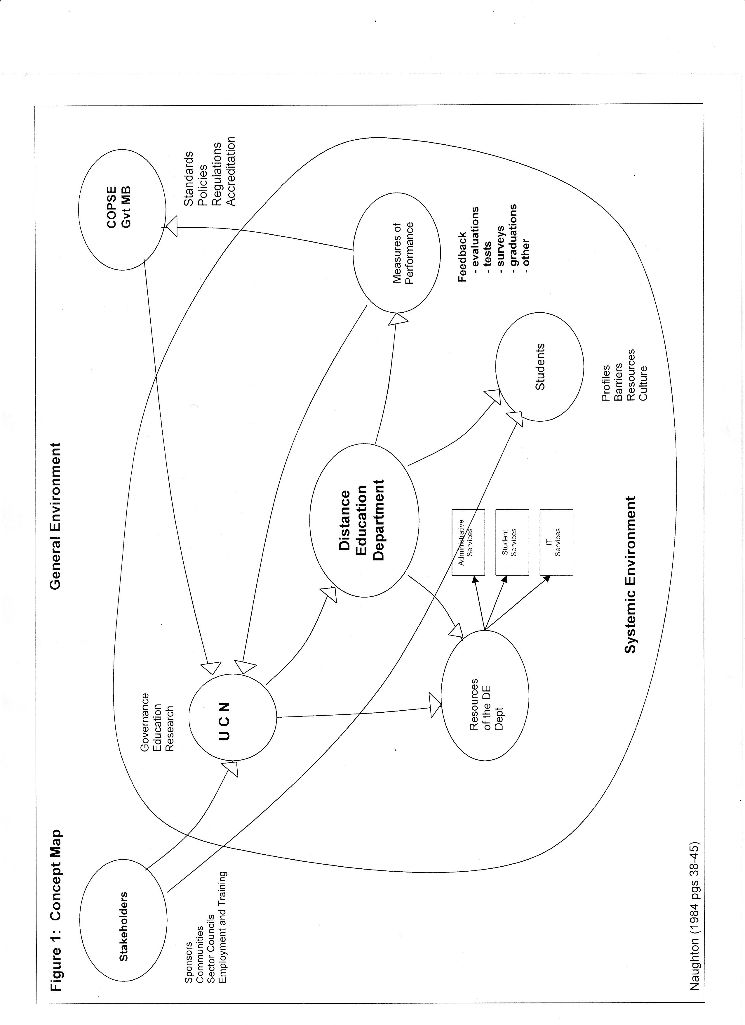
Stage 5: Comparison of Conceptual Model with Rich Picture
In reviewing the Rich Picture with the completed Concept Model there were many similarities, but also a number of differences about the activities currently taking place in the real world. The similarities were found most consistently within the systems in which there was little, or slow change. Many of the stakeholders and the COPSE system retained much of their definition from the rich picture to the conceptual model. Systems where you would expect to see similarities presented as differences within the conceptual model. It was apparent that the rapid change in mandate, educational directive, restructuring of departments, addition/changeover of faculty was creating a ripple effect across the institution in terms of instability (financial/relationship) and insecurity (staff and students). Issues abound across all departments and sectors. Separating those issues out from the immediate issues of a DE Department was tedious – and most likely incomplete. However, based on the information at hand an Agenda for discussion would likely include the following:
Table 10: Conceptual Model Agenda Setting
Conceptual Model Activities | Present in Real World | Comments
Designation of a DE Department | No | There is conflicting opinion on whether or not a designated department needs to be developed or a re-designation of existing positions and departments to support DE activities
UCN – capacity to support a DE department | ? | Concerns have been expressed about the capacity – financially and faculty-wise to support another program without negatively impacting current program commitments
Student | Yes | Many instructors are currently incorporating blended technology and teaching styles into the classroom. However, students and instructors have expressed a concern about student capacity to adopt DE systems, technology and remote styles of learning
Resources of the DE department -administrative -student supports -IT services | No | There are few current services developed to consistently support distance delivery of courses and associated services – 1) administrative – library mgmt, book store, student info system, class scheduling, financial aid and payment systems 2) Student – electronic tools, collaborative applications for participation, tutorials or help, research portals and services; portfolio; 3) IT Services – student/instructor tools, delivery applications, integrated work areas online, class mgmt supports, assessment tools, multimedia inputs and mgmt, repository functions for database, storage and access of learning objects.
Stakeholders | Yes | Dialogue and relationships currently exist in the provision of courses and supports – though not within a DE environment.
Stage 6: Debate with people involved in the situation
Due to the unresolved issues identified in the Concept Model, these activities would need to be addressed. The construction of the Agenda in Stage 5 would guide the discussions – focusing on the ‘what’ instead of the ‘how’ (Banathy, 1995). ‘What’ supports process discussion while ‘how’ questions narrow the possibilities by focusing on specific issues or pieces of the system instead of the interrelatedness of the process. Open for discussion as well is the accuracy of the rich picture used to capture the current climate of the institution and avenues of communication. If additional issues are raised at this time, it would be necessary to complete the process again to see if and how their presence changes the relevant systems and root definition. Checkland recommends the use of two filters at this stage to ensure the validity of proposed changes to the conceptual model – 1) is the change systematically desirable and 2) is the change culturally feasible? If the answer to these questions is no, then the conceptual model would stand. Affirmative responses would require an integration of the recommendations or issues into another round of soft systems analysis. If a consensus cannot be reached using this conceptual model, then a review of the relevant systems needs to be addressed. If a new Relevant system is developed then the Conceptual Model stage needs to be done again (Naughton, 1984).
Stage 7: Implementation of agreed changes
The soft systems methodology is a process that integrates change throughout the course of analysis. It integrates the perceptions, opinions, facts of the problem-situation and its environments. It then frames alternatives that are open for discussion and debate. The process itself is fairly transparent and can be a powerful change agent for organizations that have failed to acknowledge and articulate existing issues. Oftentimes, the very act of issue validation is all that will be needed to gain the cooperation of organizational participants. Checkland highlights the different types of change that might occur during the final implementation process – structural, procedural, policy or attitudinal. My prediction, based on the acceptance of the completed Conceptual Model, is that UCN would undergo several types of change to accommodate a Distance Education department.
- Structural – change in organizational groupings and departments, functional layout and responsibilities.
- Procedural – hierarchal organization of learning outcomes, course development – shifting of job tasks to create logical and sequential linkages to increase communication and reduce barriers
- Goals of the DE Department which support the institutional goals of culturally sensitive programs, processes and responsiveness
- Attitudinal – acceptance and support for centralization of distance education activities.

References
[Terralyn, use a Level one heading here.
Anderson, T. (2004). Toward a theory of online learning. In Anderson, T., & Elloumi, F. (Eds.) Theory and Practice of Online Learning (pp. 33-60). Athabasca, CA: Athabasca University.

Banathy, B. (1995). The evolution of systems inquiry. As cited in (2007) Foundations of Instructional Design: System Analysis and Learning Theory. Master of Distance Education 603 readings, Athabasca University.

Cookson, P. (1997). Settings for distance education: A comparative study of two organizational systems. ©Athabasca AB: Athabasca University. Retrieved from
www.athabascau.ca/html/staff/admin/cookson/Settings_for_distance_educaiton.doc

Du Mont, R. (May 2002). Distance learning: A systems view an assessment and review
of the literature. [Electronic version]. Kent State University. Funded in part by a grant awarded by the Ohio Learning Network in cooperation with Research Center for Educational Technology Kent State University. Retrieved January17, 2008 from http://www.rcet.org/research/ATT-OLN/Dumont-finalreport.pdf.

Frick, T. (1996). Educational Systems Theory. Retrieved January 10, 2008 from
http://www.indiana.edu/~tedfrick/edusys.html

Giroday, R. (2004). Soft System Analysis of Student Processing at Continuing and
Distance Education Services: A Rich Picture Continuing and Distance Education Services. [Electronic version]. British Columbia. Retrieved January 28, 2008 from http://giroday.thewebworks.bc.ca/MDDE/MDDE603/CDES%20Registration%20Problem%20A%20Rich%20Picture.pdf

Hart, M.A. (2002). Seeking mino-pimatisiwin: an aboriginal approach to helping.
Fernwood Publishing. Halifax, Canada.

Jarvis, C. (2003). Peter Checkland's Soft Systems Methodology [Electronic version].
BOLA Project. Retrieved January 15, 2008 from http://www.bola.biz/research/ssm.html

Littlejohn, S. (1996). System theory. In S. Littlejohn, Theories of human communication.
Belmont, CA: Thomson Learning Global Rights Group.
Malatest, R.A. (2004). Aboriginal peoples and post-secondary education:
what educators have learned.[Electronic version]. Canada Millennium Scholarship Foundation. Montreal, Qb. Canada. Retrieved September 22, 2007 from http://www.millenniumscholarships.ca/images/Publications/aboriginal_en.pdf

Mendelson, M. (July 2006). Aboriginal peoples and postsecondary education in Canada.
[Electronic version]. Caledon Institute of Social Policy. Ottawa, Canada.
Retrieved September 22, 2006 from http://www.caledoninst.org/Publications/PDF/595ENG.pdf.

Moore, M. & Kearsley, G. (2005). Distance education: A systems view. (2nd ed.).
CA:Thomson Wadsworth.

Naughton, J. (1984). Soft systems analysis: An introductory guide. Milton Keynes, UK:
The Open University Press.

Newton, P. (April 2007). Northeastern Saskatchewan aboriginal students’ perceptions of
their distance education experiences and the relationship to their aboriginal culture.[Electronic version]. Master’s thesis, Athabasca University, Athabasca, Alberta, Canada. Retrieved September 5, 2007 from http://auspace.athabascau.ca:8080/dspace/bitstream/2149/1348/1/MDE_NewtonPatThesis.pdf

Province of Manitoba (2000). Aboriginal and Northern Affairs. Aboriginal People in
Manitoba 2000. Chapter 4: Education and Training [Electronic version]. Retrieved November 5, 2007 from http://www.gov.mb.ca/ana/apm2000/4/e.html.

Province of Manitoba. (2003-2004). Bill 20: The University College of the North Act.
Legislative Assembly of Manitoba, 2nd session, 38th Legislature, November 20, 2003 - November 21, 2004. [Electronic version]. Retrieved January 17, 2008 from http://web2.gov.mb.ca/bills/38-2/b020e.php

Reigeluth, C.M. (1995). Educational Systems Development and Its Relationship ot ISD.
In G.J Anglin, (Ed.), Instructional Technology: Past, Present, and Future 2nd ed., Englewood, CO: Libraries Unlimited.

University College of the North, The Pas. (2004). 2003-2004 Annual Academic Report.
[Electronic version]. Retrieved November 12, 2007 from https://mycampus.ucn.ca/ics/Welcome/The_UCN_Community.jnz.

University College of the North, The Pas. (2005). 2004-2005 Annual Academic Report.
[Electronic version]. Retrieved November 12, 2007 from https://mycampus.ucn.ca/ics/Welcome/The_UCN_Community.jnz.

University College of the North, The Pas. (2006). 2005-2006 Annual Academic Report.
[Electronic version]. Retrieved November 12, 2007 from https://mycampus.ucn.ca/ics/Welcome/The_UCN_Community.jnz.

University College of the North, The Pas. (2007, June) Governing Council Faculty
Retreat.

University College of the North, The Pas. (June 2005). ECE Faculty Minutes.

University College of the North, The Pas, Education Division, Early Childhood
Education Faculty. (2007, November). Minutes of the Manitoba Colleges Early Childhood Education Committee.

University College of the North, The Pas. (2006). UCN Governing Council Policy
Manual (p.6). [Electronic version]. Retrieved November 12, 2007 from https://mycampus.ucn.ca/ics/Welcome/The_UCN_Community.jnz.

Walton, D. (2004). Modeling organizational systems: Banathy’s three lenses revisited.
Systemic Practice and Action Research, 17(4), 265-284.

